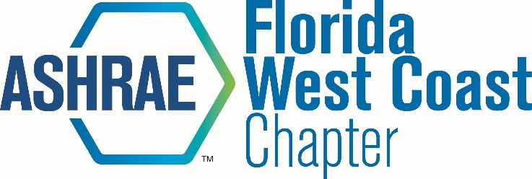 | Board Meeting Minutes

Date: October 9, 2019
Time: 12:00 PM
Location: Emerald Engineering

Attendees: Voting Members:
Thomas Morgenthau Chapter President
Tim Theriault President-Elect
Ben Hair Research Promotion
Tyler Owens Membership Promotion
Chris Janke Treasurer
Courtney Araiza Secretary
Sarah Studt Student Activities
Ethan Grabill Honors and Awards
Heather Tank Honors and Awards

Non-Voting Members:
Scott Allred Golf Tournament
Courtney Araiza Webmaster
Chris Janke Newsletter
Kat Liegl YEA
Ashley Bence YEA Co-Chair
Mike Costello Student Activities Co-Chair
Ike Crimm Co-Historian
Zach Loyacono Co-Historian
Peter Montana Publicity
Alex Glazer Reception
Christen Quintana, Reception
Ross Montgomery bEQ
Daniel Vaughn Refrigeration
Jennifer Isenbeck Co-Women In ASHRAE/Sustainability
Debie Horsey Co-Women In ASHRAE/Sustainability
Kelsey Huntzinger, Co-Women In ASHRAE/Sustainability
Tony Moreland Sarasota-Bradenton Section President
Dan Rodgers Senior Advisor

- Call to Order/ Roll Call – 12:06

- ASHRAE Code of Ethics Commitment
In this and all other ASHRAE meetings, we will act with honesty, fairness, courtesy,
competence, integrity and respect for others, and we shall avoid all real or perceived
conflicts of interests.
(See full Code of Ethics: https://www.ashrae.org/about-ashrae/ashrae-code-of-ethics.)

Tom read this to board.

- PAOE/MBO

Tyler Owens- hit minimum points for MP, goal is 418, need to add 8 members. Contemplating some new ideas for MP.
Chris Janke- on pace for budget. Deposited regional dues in bank.
Mike Costello- going to do a site visit to a mechanical room visit for USF students
Chris- get photos for newsletters
Tim- President coming in February for speaker, holiday party is December 10th at the Pub
Tim and Tyler need to coordinate MP night- March?
Last meeting with be joining with ASPE maybe?

- Adjournment – 12:30 EOM

