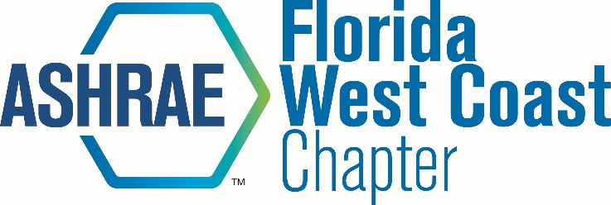 | Board Meeting Minutes

Date: April 6, 2017
Time: 12:00 PM
Location: Remote Call In

Attendees: Voting Members:
Michael Costello (MC) x Chapter President
Isaac Crimm (IC) x President-Elect
Leon Boe (LB) Research Promotion
Malia Powers (MP) x Membership Promotion
Ethan Grabill (EG) x Treasurer
Scott Manfre (SM) x Secretary
Christopher Martinez (CM) x Student Activities
Joe Cox (JC) x Honors and Awards

Non-Voting Members:
Eric Vieira (EV) x Golf Tournament
Tom Morganthau (TM) x Newsletter/Webmaster
Ashley Saint (AS) YEA
Samantha Choo Chew (SC) YEA Co-Chair
Bruce Lindsay (BL) Sustainability
Slade Fernandez (SF) Student Activities Co-Chair
Glenda Ama (GA) Student Activities Co-Chair
Dan Herrera (DH) History
Peter Montana (PM) Publicity
Michael Collins (MCO) Reception
Don Herrmann (DHE) x bEQ
David John (DJ) Refrigeration
Al Lapera (AL) Mentoring Minds
Jennifer Isenbeck (JI) x Women In ASHRAE
Alex Gicale (AG) Sarasota-Bradenton Section President

Meeting Minutes:

12:08: Meeting Started
MC: Previewed Aprils meeting (4/18). Previewed BL’s sustainability tour.
LB: LB is moving in 2 weeks. MP is taking over for RP fundraising.
MP: 3 new members.
EG: Treasurers report is looking good. 10k profit for golf tournament.
TM: Will get 2 E-blasts out before April dinner meeting. Will add Carroll Air to sponsorship page.
MC: Will start to promote shrimp boil after April meeting.
JI: Will serve as Women in ASHRAE chair next year.
12:37: Meeting Ended.

