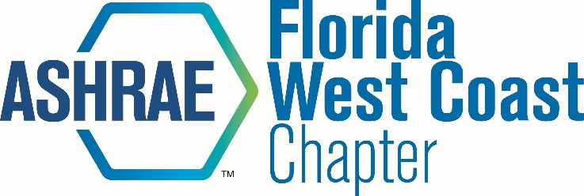 | Board Meeting Minutes

Date: March 9, 2017
Time: 12:00 PM
Location:

Attendees: Voting Members:
Michael Costello (MC) x Chapter President
Isaac Crimm (IC) President-Elect
Leon Boe (LB) Research Promotion
Malia Powers (MP) x Membership Promotion
Ethan Grabill (EG) Treasurer
Scott Manfre (SM) x Secretary
Christopher Martinez (CM) x Student Activities
Joe Cox (JC) Honors and Awards

Non-Voting Members:
Eric Vieira (EV) x Golf Tournament
Tom Morganthau (TM) Newsletter/Webmaster
Ashley Saint (AS) YEA
Samantha Choo Chew (SC) YEA Co-Chair
Bruce Lindsay (BL) x Sustainability
Slade Fernandez (SF) Student Activities Co-Chair
Glenda Ama (GA) Student Activities Co-Chair
Dan Herrera (DH) History
Peter Montana (PM) Publicity
Michael Collins (MCO) Reception
Don Herrmann (DHE) x bEQ
David John (DJ) x Refrigeration
Al Lapera (AL) Mentoring Minds
Jennifer Isenbeck (JI) Women In ASHRAE
Alex Gicale (AG) Sarasota-Bradenton Section President

Meeting Minutes:

- Meeting started at 12:07.
- EV: 13k profit from golf tournament. 3/2/18 is date for next year’s event.
- SM: BEQ luncheon is set for March 15.
- MP: 3/24 is membership night.
- CM: Updated board on status of Student Activities.
- BL: Arranging sustainability tour @ Suncoast Youth Conversation Center.
- DH: Will try to promote BEQ Luncheon.
- Meeting ended at 12:27.

